**ARMY PUBLIC SCHOOL**

**AHMEDNAGAR**

A Project Report

On

**BANK MANAGEMENT SYSTEM**

For

AISSCE 2017-2018 Examination

As a part of Informatics Practices Course

(065)

Submitted by:

Suraj Patil

Class XII A2

Under the Guidance of

Mrs. Revati Mulay

Certificate

**NAME: ______________________**

**CLASS: ______________________**

**BOARD NO. ______________________**

This is to certify that the project work entitled __________________________ has been carried out successfully during the academic year 2017-2018 in the partial fulfillment for course study for the subject Informatics Practices (065) as per the syllabus prescribed by CBSE.

**Ms. PremaMadhu Ms Nutan Mishra**

**Project guide (Principal)**

**Examiner:**

**1.**

**2.**

INDEX

|  |  |  |
| --- | --- | --- |
| S.No | Topic | Page No. |
| 1. | Acknowledgement | 4 |
| 2. | Introduction | 5 |
| 3. | MySQL Coding | 6 |
| 4. | Java Coding And Screenshots |  |
| 5. | Merits And Demerits |  |
| 6. | Conclusion And Future Enhancements |  |
| 7. | Bibliography |  |

Acknowledgement

Believe it or not but IT applications are indispensable part of our lives. In this digital age we can’t imagine without IT applications that gets everything on our finger tips.

For example we can easily

* Access financial information , weather forecasts , latest news etc.;
* Manage our daily activities of scheduling , preparing timetables, appointments etc.;
* Communicate or conduct video conference for businesses;
* Conduct our financial transactions;
* Entertain and amuse ourselves;

If we go by the estimates of Portion Research there will be around 4.4 billion mobile app users across the globe by 2018, with a compound annual growth rate of 29.8 per cent each year from the end of 2012 when there were only 1.2 billion mobile app users.

And because such in the scale of demands, no. of entrepreneurs, app publishers, sellers, app marketers and developers dealing and doing mobile app development business is also elevating, turning mobile app industry a booming and zooming markets.

**Suraj Patil**

INTRODUCTION

Believe it or not but IT applications are indispensable part of our lives. In this digital age we can’t imagine without IT applications that gets everything on our finger tips.

For example we can easily

* Access financial information , weather forecasts , latest news etc;
* Manage our daily activities of scheduling , preparing timetables, appointments etc;
* Communicate or conduct video conference for businesses;
* Conduct our financial transactions;
* Entertain and amuse ourselves;

If we go by the estimates of Portion Research there will be around 4.4 billion mobile app users across the globe by 2017, with a compound annual growth rate of 29.8 per cent each year from the end of 2012 when there were only 1.2 billion mobile app users.

And because such in the scale of demands, no. of entrepreneurs, app publishers, sellers, app marketers and developers dealing and doing mobile app development business is also elevating, turning mobile app industry a booming and zooming markets.

Mysql coding

Code for Creation of table ‘Project1’ :--

“ **create table Project1(S_No int(10),**

**Customer_Type char(10),**

**Name_Of_Holder varchar(30),**

**Gender char(10),**

**Name_Of_Father varchar(30),**

**Name_Of_Mother varchar(30),**

**Date_Of_Birth date,**

**Marital_Status char(10),**

**Nationality char(10),**

**Local_Address varchar(30),**

**Permanent_Address varchar(30),**

**Phone_No int(12),**

**Mobile_No int(12),**

**Account_No int(10);”**

Table Description :--

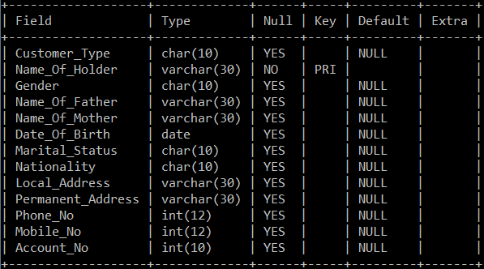

Code for Creation of table ‘Project2’ :--

**“create table project2(Name_Of_Holder char(30),**

**Account_No int(10),**

**Balance double,**

**foreign key(Name_Of_Holder) references project1(Name_Of_Holder) on update cascade on delete cascade);”**

Table Description :--

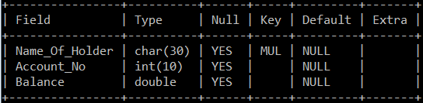

java coding and screenshots

[I] ‘Welcome’ Frame:--

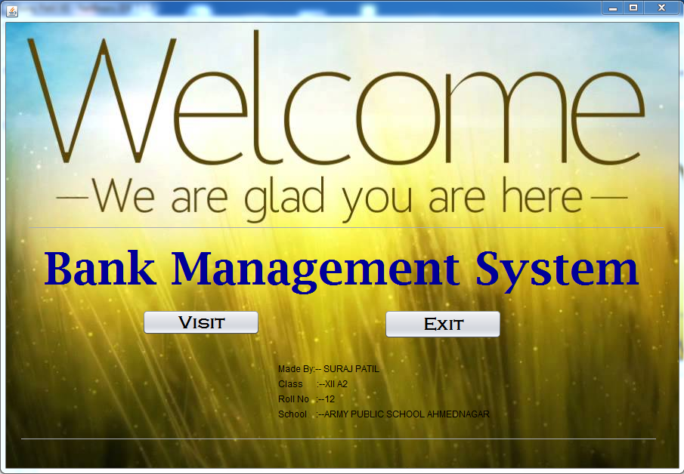

Coding For Visit Button :--

“**obj.setVisible(true);**

**this.setVisible(false);”**

Coding For Exit Button :--

**“System.exit(0);**”

[II] Login Form:--

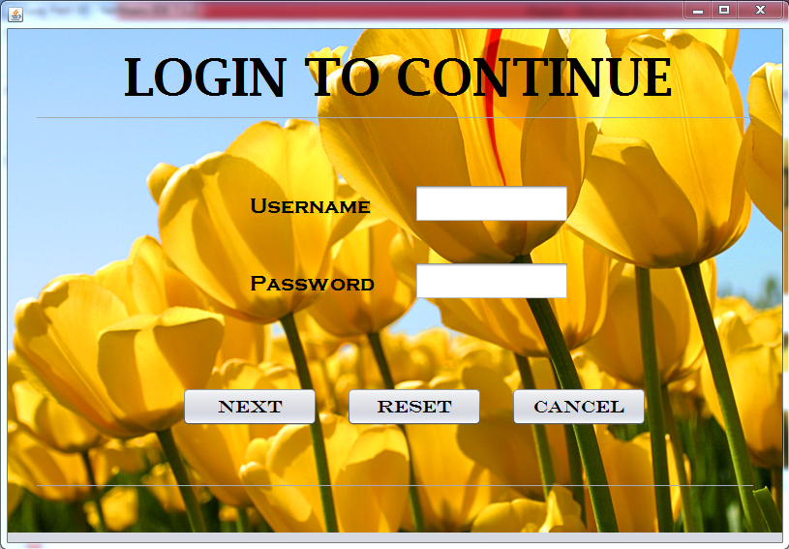

Coding For Next Button :--

“**String s1;**

**String x;**

**s1=jTextField1.getText();**

**x=new String(jPasswordField1.getPassword());**

**if(s1.equalsIgnoreCase("Suraj") && x.equals("Welcome")){**

**JOptionPane.showMessageDialog(this,"Login Successfull!");**

**C_MainForm obj1=new C_MainForm();**

**obj1.setVisible(true);**

**this.setVisible(false);**

**}**

**else**

**JOptionPane.showMessageDialog(this,"You have entered**

**wrong Username or Password");**”

Code For Reset Button :--

“**jTextField1.setText(null);**

**jPasswordField1.setText(null);**”

Code For Cancel Button :--

“**System.exit(0);**”

[III] Mainform Frame:--

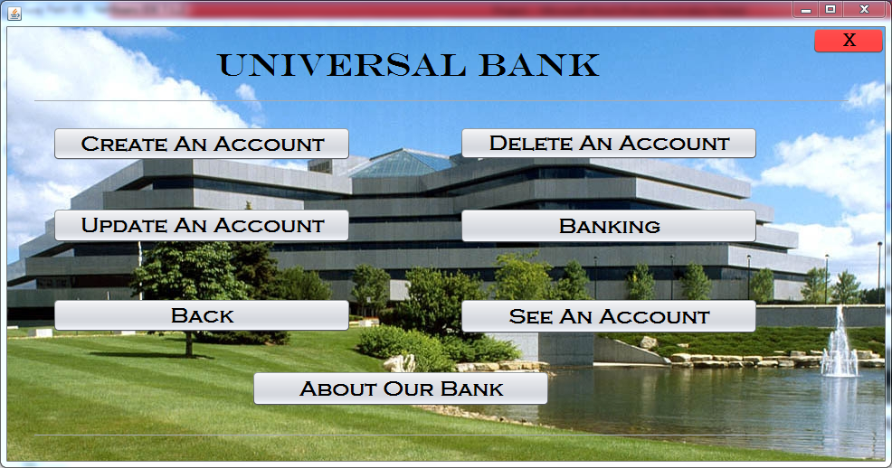

Code For ‘Create An Account’ Button :--

“**Creation_of_Acc obj4=new Creation_of_Acc();**

**obj4.setVisible(true);**

**this.setVisible(false);**”

Code For ‘Delete An Account’ Button :--

“**DeleteAnAcc obj5=new DeleteAnAcc();**

**obj5.setVisible(true);**

**this.setVisible(false);**”

Code For ‘Update An Account’ Button :--

“**UpdateAnAcc obj7=new UpdateAnAcc();**

**obj7.setVisible(true);**

**this.setVisible(false);**”

Code For ‘Banking’ Button :--

“**Banking obj6=new Banking();**

**obj6.setVisible(true);**

**this.setVisible(false);**”

Code For ‘Back’ Button :--

“**obj3.setVisible(true);**

**this.setVisible(false);**”

Code For ‘See An Account’ Button :--

“**SeeAnAccount obbj=new SeeAnAccount();**

**obbj.setVisible(true);**

**this.setVisible(false);**”

Code For ‘About Our Bank’ Button :--

“**JOptionPane.showMessageDialog(null,"Want to put your**

**money in a safe hand ? Join our bank and get the most**

**convenient facilities for all.");**”

[IV] Create An Account Frame :--

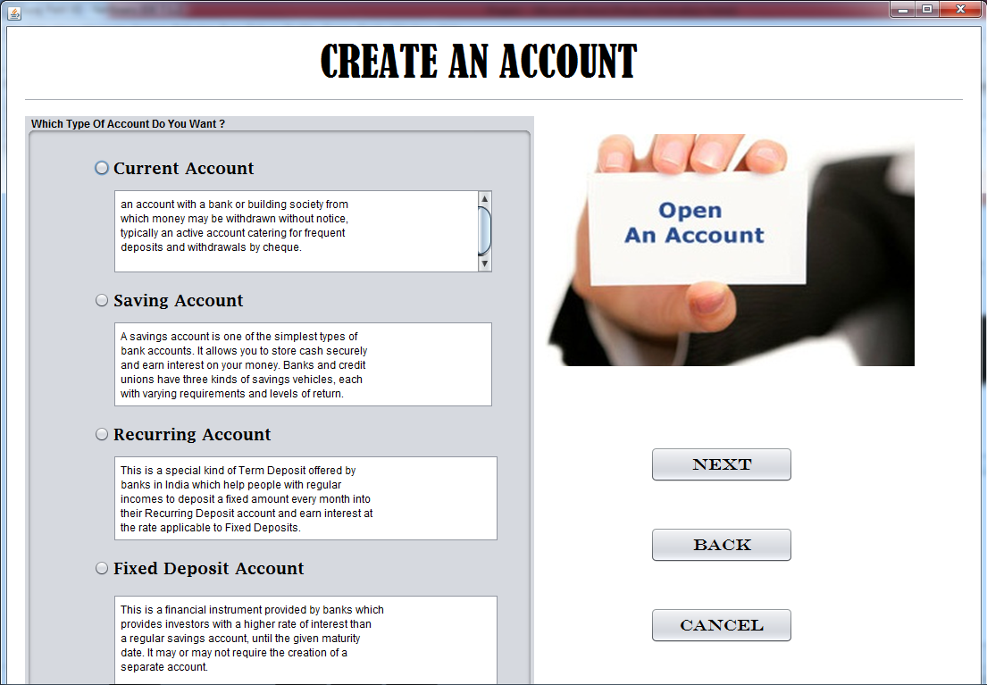

Code For ‘Next’ Button :--

“**InfoOfHolder obj9=new InfoOfHolder();**

**obj9.setVisible(true);**

**this.setVisible(false);**”

Code For ‘Back’ Button :--

“**C_MainForm obj8=new C_MainForm();**

**obj8.setVisible(true);**

**this.setVisible(false);**”

Code For ‘Cancel’ Button :--

“**System.exit(0);**”

[V] Deletion Of Account Frame :--

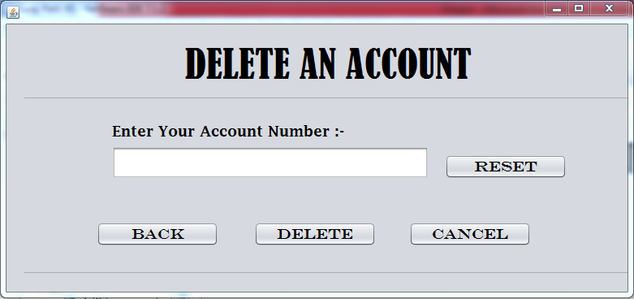

Code For ‘Reset’ Button :--

“**jTextField1.setText(null);**”

Code For ‘Back’ Button :--

“**C_MainForm objx=new C_MainForm();**

**objx.setVisible(true);**

**this.setVisible(false);**”

Code For ‘Delete’ Button :--

“**int y=JOptionPane.showConfirmDialog(null,"Are you sure you**

**want to delete the record from the database?");**

**if(y==JOptionPane.YES_OPTION)**

**{**

**try{**

**Class.forName("java.sql.Driver");**

**System.out.println("1");**

**Connection conc=DriverManager.getConnection("jdbc:mysql://localhost/suraj","root","tiger");**

**System.out.println("2");**

**Statement smt=conc.createStatement();**

**System.out.println("3");**

**String query="delete from project2 "+**

**"where Account_No="+**

**Integer.parseInt(jTextField1.getText())+";";**

**System.out.println("4");**

**smt.executeUpdate(query);**

**System.out.println("5");**

**JOptionPane.showMessageDialog(null,"Record successfully**

**deleted.");**

**}**

**catch(Exception a){**

**JOptionPane.showMessageDialog(null,"Error in**

**deletion!");**

**}**

**} jTextField1.setText(null);**”

Code For ‘Cancel’ Button :--

“**System.exit(0);**”

[VI] Banking Frame :--

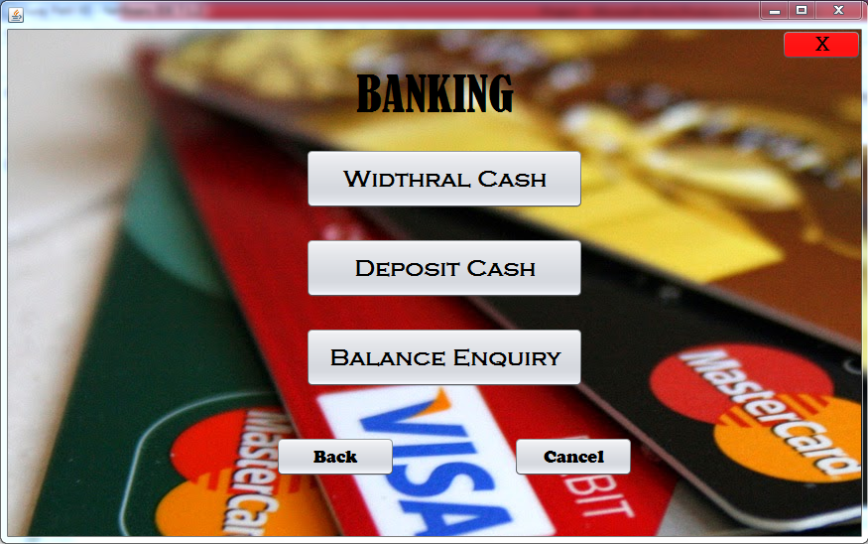

Code For ‘Widthral’ Button :--

“**CashWid ob1=new CashWid();**

**ob1.setVisible(true);**

**this.setVisible(false);**”

Code For ‘Deposit’ Button :--

“**DepositCash ob2=new DepositCash();**

**ob2.setVisible(true);**

**this.setVisible(false);**”

Code For ‘Balance Enquiry’ Button :--

“**BalanceEnquiry ob3=new BalanceEnquiry();**

**ob3.setVisible(true);**

**this.setVisible(false);**”

Code For ‘Back’ Button :--

“**C_MainForm obj9=new C_MainForm();**

**obj9.setVisible(true);**

**this.setVisible(false);**”

Code For ‘Cancel’ Button :--

“**System.exit(0);**”

[VII] Update An Account Frame

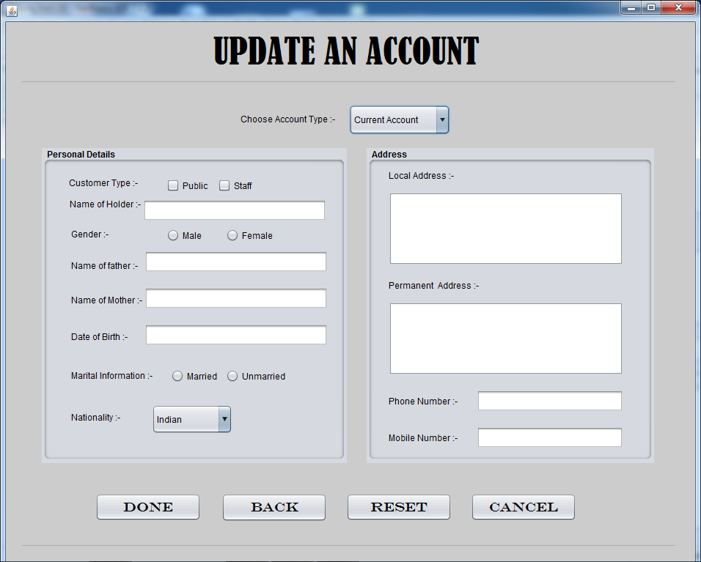

Code For ‘Done’ Button :--

“**int y=JOptionPane.showConfirmDialog(null,"Are you sure you**

**want to update this record from the table?");**

**if(y==JOptionPane.YES_OPTION)**

**{**

**{**

**String s1;**

**{**

**if(jCheckBox3.isSelected()==true)**

**s1="Public";**

**else**

**s1="Staff";**

**}**

**System.out.println(s1);**

**String s2;**

**{**

**if(jRadioButton3.isSelected()==true)**

**s2="Male";**

**else**

**s2="Female";**

**}**

**System.out.println(s2);**

**String s3;**

**{**

**if(jRadioButton5.isSelected()==true)**

**s3="Married";**

**else**

**s3="Unmarried";**

**}**

**System.out.println(s3);**

**String s4=(String)jComboBox1.getSelectedItem();**

**System.out.println(s4);**

**String s5=(String)jTextArea1.getText();**

**System.out.println(s5);**

**String s6=(String)jTextArea2.getText();**

**System.out.println(s6);**

**try{**

**Class.forName("java.sql.Driver");**

**System.out.println("E1");**

**Connection**

**cont=DriverManager.getConnection("jdbc:mysql://localhost/suraj","root","tiger");**

**System.out.println("E2");**

**Statement stat=cont.createStatement();**

**System.out.println("E3");**

**String query="insert into project1 values"**

**+ "(\'"+s1+"\',\'"+**

**jTextField2.getText()+"\'"+",\'"**

**+s2+"\',\'"+**

**jTextField3.getText()+"\',\'"+**

**jTextField4.getText()+"\',\'"+**

**jTextField5.getText()+"\',\'"+**

**s3+"\',\'"+**

**s4+"\',\'"+**

**s5+"\',\'"+**

**s6+"\',"+**

**Integer.parseInt(jTextField1.getText())+**

**","+Integer.parseInt(jTextField6.getText())+");";**

**System.out.println("E4");**

**stat.executeUpdate(query);**

**System.out.println("E5");**

**stat.close();**

**cont.close();**

**System.out.println("E6");**

**JOptionPane.showMessageDialog(this,"Account Updated Successfully!");**

**}**

**catch(Exception x){**

**JOptionPane.showMessageDialog(this,"Error in connectivity!");**

**}**

**}**

**}**”

Code For ‘Back’ Button :--

“**C_MainForm objy=new C_MainForm();**

**objy.setVisible(true);**

**this.setVisible(false);**”

Code For ‘Reset’ Button :--

“**jTextField1.setText(null);**

**jTextField2.setText(null);**

**jTextField3.setText(null);**

**jTextField4.setText(null);**

**jTextField5.setText(null);**

**jTextField6.setText(null);**

**jTextArea1.setText(null);**

**jTextArea2.setText(null);**”

Code For ‘Cancel’ Button :--

“**System.exit(0);**”

[VII] See An Account Frame :--

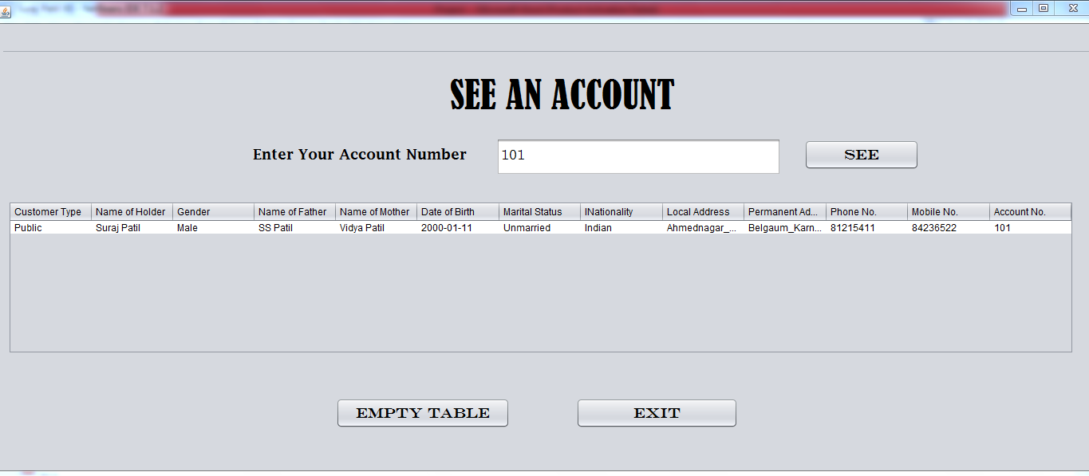

Code For ‘See’ Button :--

“**int x=Integer.parseInt(jTextField1.getText());**

**DefaultTableModel model=(DefaultTableModel)jTable1.getModel();**

**try{**

**Class.forName("java.sql.Driver");**

**System.out.println("E1");**

**Connection con=DriverManager.getConnection("jdbc:mysql://localhost/suraj","root","tiger");**

**Statement stmt=con.createStatement();**

**System.out.println("E2");**

**String query="Select * from project1 where**

**Account_No="+x+";";**

**System.out.println("E3");**

**ResultSet rs=stmt.executeQuery(query);**

**System.out.println("E4");**

**while(rs.next())**

**{**

**String s1=rs.getString("Customer_Type");**

**System.out.println("E5");**

**String s2=rs.getString("Name_Of_Holder");**

**System.out.println("E6");**

**String s3=rs.getString("Gender");**

**System.out.println("E7");**

**String a=rs.getString("Name_Of_Father");**

**System.out.println("E8");**

**String m=rs.getString("Name_Of_Mother");**

**System.out.println("E9");**

**Date r=rs.getDate("Date_Of_Birth");**

**System.out.println("E10");**

**String f=rs.getString("Marital_Status");**

**System.out.println("E11");**

**String h=rs.getString("Nationality");**

**System.out.println("E12");**

**String sr=rs.getString("Local_Address");**

**System.out.println("E13");**

**String b=rs.getString("Permanent_Address");**

**System.out.println("E14");**

**int s4=rs.getInt("Phone_No");**

**System.out.println("E15");**

**int s5=rs.getInt("Mobile_No");**

**System.out.println("E16");**

**int s6=rs.getInt("Account_No");**

**System.out.println("E17");**

**model.addRow(new Object[] {s1,s2,s3,a,m,r,f,h,sr,b,s4,s5,s6});**

**System.out.println("E18");**

**}**

**System.out.println("E19");**

**rs.close();**

**stmt.close();**

**con.close();**

**System.out.println("E20");**

**}**

**catch(Exception e){**

**JOptionPane.showMessageDialog(null, "Error in connectivity");**

**}**”

Code For ‘Empty Table’ Button :--

“**DefaultTableModel model = (DefaultTableModel)jTable1.getModel();**

**model.setRowCount(0);**”

Code For ‘Exit’ Button :--

“**System.exit(0);**”

[VIII] Holder Info Frame :--

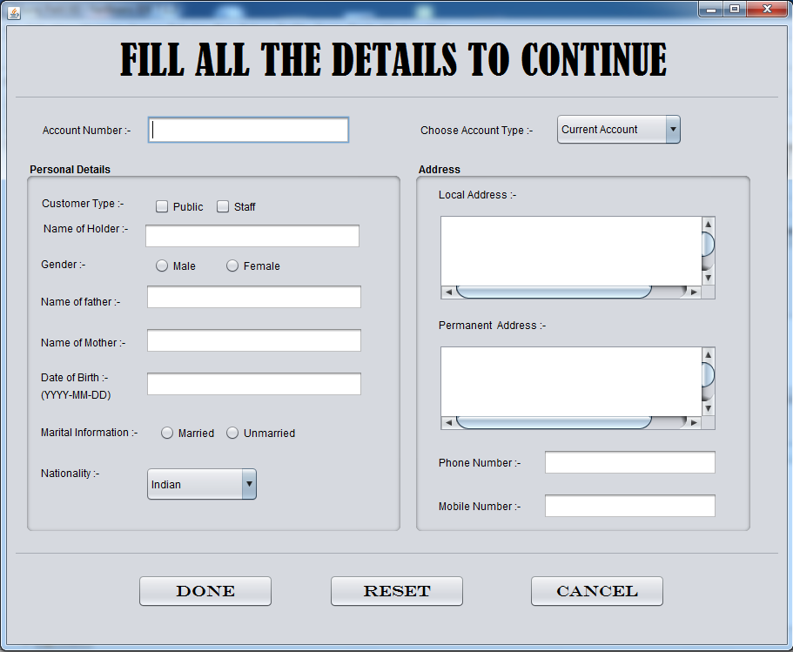

Code For ‘Done’ Button :--

“**String s1;**

**{**

**if(jCheckBox3.isSelected()==true)**

**s1="Public";**

**else**

**s1="Staff";**

**}**

**System.out.println(s1);**

**String s2;**

**{**

**if(jRadioButton3.isSelected()==true)**

**s2="Male";**

**else**

**s2="Female";**

**}**

**System.out.println(s2);**

**String s3;**

**{**

**if(jRadioButton5.isSelected()==true)**

**s3="Married";**

**else**

**s3="Unmarried";**

**}**

**System.out.println(s3);**

**String s4=(String)jComboBox1.getSelectedItem();**

**System.out.println(s4);**

**String s5=(String)jTextArea1.getText();**

**System.out.println(s5);**

**String s6=(String)jTextArea2.getText();**

**System.out.println(s6);**

**try{**

**Class.forName("java.sql.Driver");**

**System.out.println("E1");**

**Connection cont=DriverManager.getConnection("jdbc:mysql://localhost/suraj","root","tiger");**

**System.out.println("E2");**

**Statement stat=cont.createStatement();**

**System.out.println("E3");**

**String query1="insert into project1 values"**

**+ "(\'"+s1+"\',\'"+**

**jTextField2.getText()+"\'"+",\'"**

**+s2+"\',\'"+**

**jTextField3.getText()+"\',\'"+**

**jTextField4.getText()+"\',\'"+**

**jTextField5.getText()+"\',\'"+**

**s3+"\',\'"+**

**s4+"\',\'"+**

**s5+"\',\'"+**

**s6+"\',"+**

**Integer.parseInt(jTextField1.getText())+**

**","+Integer.parseInt(jTextField6.getText())+**

**","+Integer.parseInt(jTextField7.getText())+**

**");";**

**stat.executeUpdate(query1);**

**System.out.println("E4");**

**double x=0.00;**

**String query2="insert into project2 values(\""+**

**jTextField2.getText()+"\","+**

**Integer.parseInt(jTextField7.getText())+","+**

**x+");";**

**System.out.println("E5");**

**stat.executeUpdate(query2);**

**System.out.println("E6");**

**stat.close();**

**cont.close();**

**System.out.println("E7");**

**JOptionPane.showMessageDialog(this,"Account Created Successfully!");**

**}**

**catch(Exception e){**

**JOptionPane.showMessageDialog(this,"Error in connectivity!");**

**}**”

Code For ‘Reset’ Button :--

“**jTextField1.setText(null);**

**jTextField2.setText(null);**

**jTextField3.setText(null);**

**jTextField4.setText(null);**

**jTextField5.setText(null);**

**jTextField6.setText(null);**

**jTextArea1.setText(null);**

**jTextArea2.setText(null);**”

Code For ‘Cancel’ Button :--

“**System.exit(0);**”

[IX] Cash Withdrawal Frame :--

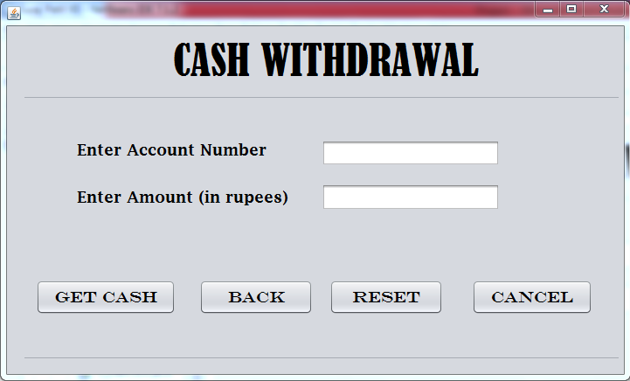

Cade For ‘Get Cash’ Button :--

“**int s1=Integer.parseInt(jTextField1.getText());**

**int s2=Integer.parseInt(jTextField2.getText());**

**try{**

**Class.forName("java.sql.Driver");**

**System.out.println("E1");**

**Connection cont=DriverManager.getConnection("jdbc:mysql://localhost/suraj","root","tiger");**

**System.out.println("E2");**

**Statement stat=cont.createStatement();**

**System.out.println("E3");**

**String query="select Balance from project2 where Account_No="+s1+";";**

**System.out.println("E4");**

**ResultSet rs=stat.executeQuery(query);**

**System.out.println("E5");**

**rs.next();**

**double s3=rs.getDouble("Balance");**

**System.out.println("E6");**

**if(s2<s3)**

**{**

**System.out.println(s2);**

**String query2="update project2 set Balance=Balance-"+s2**

**+ " where Account_No="+s1+";";**

**System.out.println("E7");**

**stat.executeUpdate(query2);**

**System.out.println("E8");**

**JOptionPane.showMessageDialog(this,"Please Collect Your Cash!");**

**}**

**else**

**JOptionPane.showMessageDialog(this,"Your entered amount is greater than your balance amount!"**

**+" Please enter another amount less than your balance Amount!");**

**System.out.println("E9");**

**cont.close();**

**stat.close();**

**rs.close();**

**System.out.println("E10");**

**}**

**catch(Exception e){**

**JOptionPane.showMessageDialog(this,"Error in Connectivity");**

**}”**

Cade For ‘Back’ Button :--

**“Banking ob=new Banking();**

**ob.setVisible(true);**

**this.setVisible(false);**”

Cade For ‘Reset’ Button :--

“**jTextField1.setText(null);**

**jTextField2.setText(null);**”

Cade For ‘Cancel’ Button :--

“**System.exit(0);**”

[X] Deposit Cash Frame :--

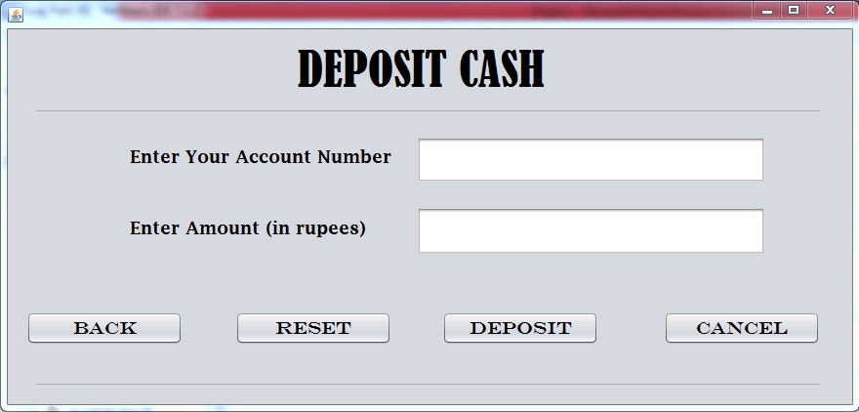

Code For ‘Back’ Button :--

“**Banking objr=new Banking();**

**objr.setVisible(true);**

**this.setVisible(false);**”

Code For ‘Reset’ Button :--

“**jTextField1.setText(null);**

**jTextField2.setText(null);**”

Code For ‘Deposit’ Button :--

“**int s1=Integer.parseInt(jTextField1.getText());**

**double s2=Double.parseDouble(jTextField2.getText());**

**try{**

**Class.forName("java.sql.Driver");**

**System.out.println("E1");**

**Connection cont=DriverManager.getConnection("jdbc:mysql://localhost/suraj","root","tiger");**

**System.out.println("E2");**

**Statement stat=cont.createStatement();**

**System.out.println("E3");**

**String query1="update project2"+**

**"set Balance=Balance+"+s2+**

**"where Account_No="+s1+";";**

**System.out.println("E4");**

**stat.executeQuery(query1);**

**System.out.println("E5");**

**cont.close();**

**stat.close();**

**System.out.println("E6");**

**JOptionPane.showMessageDialog(this,"Cash Deposited Successfully.");**

**}**

**catch(Exception e){**

**JOptionPane.showMessageDialog(this,"Error in Connection!");**

**}**”

Code For ‘Cancel’ Button :--

“**System.exit(0);**”

[XI] Balance Enquiry Frame :--

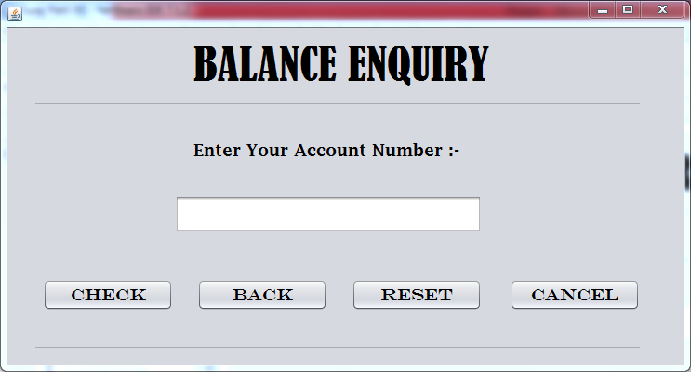

Code For ‘Check’ Button :--

“**int s1=Integer.parseInt(jTextField1.getText());**

**try{**

**Class.forName("java.sql.Driver");**

**System.out.println("E1");**

**Connection cont=DriverManager.getConnection("jdbc:mysql://localhost/suraj","root","tiger");**

**System.out.println("E2");**

**Statement stat=cont.createStatement();**

**System.out.println("E3");**

**String query1="select Balance from project2;";**

**System.out.println("E4");**

**ResultSet rs=stat.executeQuery(query1);**

**System.out.println("E5");**

**rs.next();**

**double s2=rs.getDouble("Balance");**

**System.out.println("E6");**

**JOptionPane.showMessageDialog(this,"Your Balance Amount is Rs. "+s2);**

**System.out.println("E7");**

**cont.close();**

**stat.close();**

**rs.close();**

**System.out.println("E8");**

**}**

**catch(Exception x){**

**JOptionPane.showMessageDialog(this,"Error in Connectivity");**

**}**”

Code For ‘Back’ Button :--

“**Banking ob=new Banking();**

**ob.setVisible(true);**

**this.setVisible(false);**”

Code For ‘Reset’ Button :--

“**jTextField1.setText(null);**”

Code For ‘Cancel’ Button :--

“**System.exit(0);**”

MERITS-DEMERITS AND BIBLOGRAPHY

**Merits:**

1. Reduces human time and effort.
2. Increases efficiency of the work done.
3. Brings consistency in work, which otherwise might have a lot of potential errors.
4. Brings transparency.

**Demerits:**

1. Can cause big problems if the code is wrong.

BIBLOGRAPHY

1. Sumita Arora class 12 and 11 Informatics Practices Textbook

weblioGRAPHY

1. [www.wcschools.com](http://www.wcschools.com)